Version 2.0

ECE Department

Portland State university

ECE 211 Intro to Design Processes

Lab-A2

**Lab-A2**

# Required Hardware & Software

* Arduino UNO Rev 3 microcontroller board and kit (-*or*- compatible clone)
* Your own laptop or desktop computer
* Arduino hardware drivers and Arduino Desktop IDE software
* Access to D2L

# Introduction

In this second Arduino lab, you will work with more sensors, a joystick, and a two-line LCD display unit. Your tasks are:

* Follow the instructions for the given lesson.
  + You will download lessons and code from D2L, construct a small circuit, and run the sample code. You will have the chance to enhance the programs later.
* Answer a few questions on a worksheet and upload it on D2L.
* Demonstrate your work to your Scrum Master (helper).

# Libraries (READ THIS)

The low-level code for interfacing hardware components to an Arduino is often complex. To make programming easier, pre-written high-level C functions are available to access specific models of input and output devices. The code for these functions is collected into a library package. Libraries for controlling the most common components are already pre-installed.

For more specialized hardware, you can download additional libraries, which are distributed in ZIP files. Importing a library into the Arduino Desktop IDE is very simple. Go to the IDE main menu and select Sketch → Include Library → Add ZIP Libraries … . When the file selection dialog appears, pick the library ZIP file you want to add and then click the [Open] button. This process only needs to be once, and the library will be available from then on.

Note: If a library needed by your hardware is not loaded, compilation of your program will fail.

# Part 1: More Sensors

Download these files[1] from D2L:

|  |  |  |
| --- | --- | --- |
| Lesson | Code | Libraries |
| *2.9 Ultrasonic Sensor Module.pdf* | SR04_Example.ino | HC-SR04.zip |
| *2.10 DHT11 Temperature and Humidity Sensor.pdf* | DHT11_example.ino | DHT.zip |

Install both sensor libraries. Notes:

* The SR04 module transmits ultrasonic sound waves out and uses the timing of the reflected wave back to determine the distance between the sensor and an object.
* The SR04 sensor included with the kit looks like this:

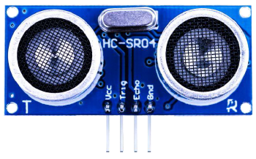

From the front of the SR04 module, the pins are:

Vcc Trig Echo Gnd

V T E G

* The DHT11 sensor has this appearance:

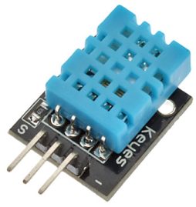

**WARNING:** Some of DHT11 sensor pictures in the guide show four pins. This is not the same model that is included in the kit!

The kit’s actual sensor has three pins in this order:

Data Vcc Gnd

D

V

G

**► Perform Exercise 1 in the worksheet.**

# Part 2: Joystick

Download these files from D2L:

|  |  |  |
| --- | --- | --- |
| Lesson | Code | Libraries |
| *2.11 Analog Joystick Module.pdf* | Analog_Joystick.ino |  |

Notes:

* The joystick has an integrated switch (push down on the joystick’s cap).

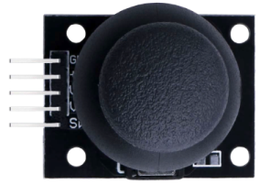

**► Perform Exercise 2 in the worksheet.**

# Part 3: IR Remote Control

Download these files from D2L:

|  |  |  |
| --- | --- | --- |
| Lesson | Code | Libraries |
| *2.12 IR Receiver Module.pdf* | IR_Receiver_Module.ino | IRremote.zip |

Install the IR remote library. Notes:

* The IR (infrared) sensor detects the coded signals emitted by the remote control.
* This sensor looks like this:

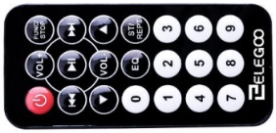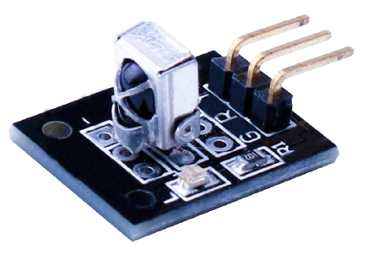

Remote control unit

The pins are:

G - Ground

R - Vcc (+5 V)

Y - Data

* The remote control should be directly aimed at the IR sensor. The buttons are somewhat “twitchy”, so sometimes the decoded command may be incorrect.

**► Perform Exercise 3 in the worksheet.**

# Part 4: LCD Display

Download these files from D2L:

|  |  |  |
| --- | --- | --- |
| Lesson | Code | Libraries |
| *2.13 LCD Display.pdf* | HelloWorld.ino |  |

Notes:

* The LCD display shows 2 rows of 16 characters and is fully programmable.
* This is the display unit:
* 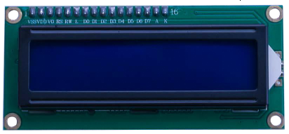
* Be VERY careful wiring up the LCD display to the Arduino! Do not connect the VDD (power) wire until you have double-checked your connections.

**► Perform Exercise 4 in the worksheet.**

This section will be posted on D2L separately as Word document. Use that file to write your report. It is included here for completeness so that you have everything in one place.

**ECE 211 Lab-A2 – Worksheet**

Name: .

**Exercise 1**

***Part 1A:*** Follow the instructions in the lesson *2.9 Ultrasonic Sensor Module* and run the code.

1. In the table below, fill in the measured distance as reported by the sensor versus the actual distance. If you do not have a ruler or a measuring tape you can use a standard sheet of U.S. letter sized paper that is 11 inches in height as a standard reference.

|  |  |  |  |
| --- | --- | --- | --- |
| Reference | Actual Distance | Reported Distance (cm) | % Relative error |
| 2× | 22” (56 cm) |  |  |
| 1× | 11” (28 cm) |  |  |
| ½ × | 5.5” (14 cm) |  |  |
| ¼ × | 2.25” ( 7 cm) |  |  |

1. **Ask your Scrum Master to verify** that your setup is working.
2. In the box below, comment on the accuracy of the sensor. Does the relative error change much as a function of the actual distance? Does the shape or hardness of the reflecting surface make any difference? Suggest a way you could compensate for the errors.

***Part 1B:*** Follow the instructions in the lesson *2.10 DHT11 Temperature and Humidity Sensor* and run the code.

1. **Ask your Scrum Master to verify** that your setup is working.
2. Question: Does the reported temperature seem reasonable for the room? What happens if you breath on the sensor? Write you answers in the box below.

**Exercise 2**

Follow the instructions in the lesson *2.11 Analog Joystick Module* and run the code.

1. **Ask your Scrum Master to verify** that your setup is working.

**Exercise 3**

1. First, do the lesson *2.12 IR Receiver Module* exactly as written to get a functioning IR circuit. Look the code over carefully to see how it works. You do not need your Scrum Master to verify this part.
2. Next, connect three LEDs of different colors to the Arduino. Remember to insert a 220 Ω resistor in series with each LED. When you press the number keys 1, 2, or 3 on the remote control’s keypad, its associated LED should light up, while the others remain off.
3. **Ask your Scrum Master to verify** that your setup is working.
4. Once you are done, upload your modified IR program (.ino) to D2L.

**Exercise 4**

1. First, do the lesson *2.13 LCD Display*. The wiring is fairly complicated, so take your time, be neat, and double-check your work. Do not connect the VDD power wire until you are ready. Examine the code carefully. You do not need your Scrum Master to verify this part.
2. Now connect the joystick to the circuit.
3. Edit the program so that the joystick’s current x and y values are displayed continuously on the LCD module instead of to the Serial Monitor screen on the host PC.

* The reported x and y values normally have a range from 0 to 1023. The centered position of the joystick should be around x=512 and y=512 (i.e., mid-range).
* Change the code so that a centered joystick displays x=0 and y=0 coordinates. This means other joystick positions can show either negative or positive numbers.

1. **Ask your Scrum Master to verify** that your setup is working.
2. Once you are done, upload your modified LCD program (.ino) to D2L.
3. **Upload this completed worksheet with your name and answers on D2L**
4. **Upload your Exercise 3 and 4 Arduino .ino programs to the Lab-A2 Submission Folder on D2L.**

1. **COPYRIGHT NOTICE:** All of the lesson guides are extracted from the original Elegoo V1.0.17.7.9 tutorial document. Elegoo Inc. and Simon Monk retain full copyrights on all of the guide content.